The Green Hydrogen Organisation (GH2)

The Green Hydrogen Standard

Green Hydrogen projects that meet the Green Hydrogen Standard will be licensed to use the label “GH2 Green Hydrogen” and will be eligible to obtain and trade GH2 certificates of origin for green hydrogen and derivatives such as green ammonia.

Draft for public comment – 15 March 2022
Please submit any comments to Sam Bartlett (sam.bartlett@gh2.org) by 1 April 2022.

Anti-trust statement. GH2 seeks to fully comply with all applicable laws, including antitrust and competition laws and regulations. Stakeholders involved in the development of the Standard shall not discuss or share confidential proprietary or otherwise commercially sensitive information including pricing, terms and conditions of sale, production or sales levels, business relations, or other matters on which participants compete. Discussing or sharing this information can have serious consequences for GH2 and participants including fines and reputational damage.

The Green Hydrogen Organisation (GH2)
The Green Hydrogen Organisation (GH2) is a not profit foundation under Swiss law. In addition to its office in Geneva it is present in London, Perth, and Sydney.
The mission of GH2 is to dramatically accelerate the production and utilisation of green hydrogen across a range of sectors globally. It will push to rapidly decarbonise industries like steel, cement, fertilisers, shipping and aviation that have so far made limited progress reducing their emissions.
A global standard that defines green hydrogen is essential to promote confidence, raise and leverage investment, facilitate trade and unlock green hydrogen’s vast potential.
Additional information regarding GH2 is available via www.gh2.org

The Green Hydrogen Standard
The Green Hydrogen Organisation
Draft Version 2 15 March 2022

This publication may be reproduced free of charge in
any format or medium provided that it is reproduced
accurately and not used in a misleading context.
The material must be acknowledged as the
Green Hydrogen Organisation copyright with the
title and source of the publication specified.
Copyright in the typographical arrangement and design
rests with the Green Hydrogen Organisation.
.

Foreword
Lorem ipsum dolor sit amet, consectetur adipiscing elit. Duis rutrum elementum mi, eu consequat erat sagittis nec. Sed eleifend convallis odio, a tempor erat tincidunt id. Pellentesque habitant morbi tristique senectus et netus et malesuada fames ac turpis egestas. Nulla tempor vulputate dictum. Sed condimentum id turpis posuere efficitur. Sed justo turpis, gravida nec tellus ut, varius pulvinar diam. Curabitur at consequat augue. Ut imperdiet turpis ligula, pellentesque rutrum nunc egestas vehicula.
Nam vel vulputate ante. Aenean posuere, arcu sed pharetra semper, risus massa fermentum mauris, tincidunt rhoncus quam est eget diam. Ut convallis tellus vel volutpat fringilla. Mauris id hendrerit nibh. Sed non justo nunc. Duis augue justo, volutpat in placerat eu, imperdiet at elit. Nam accumsan mattis condimentum. Morbi ornare enim sed arcu tincidunt pellentesque. Morbi sagittis, elit non sodales finibus, ex lacus aliquam lacus, nec posuere nisi odio et nibh. Praesent sit amet augue ac neque tempor placerat quis quis velit.
GH2 Board
April 2022

Acknowledgments
In December 2021 the GH2 formed a Technical Committee to advise the GH2 Board on the development of the Standard. The Green Hydrogen Organisation thanks the following organisations and individuals for their advice and input:
[TBC]

1. Introduction
Green hydrogen producers are invited to submit their projects for accreditation and certification by the Green Hydrogen Organisation (GH2). Green Hydrogen projects that meet the Green Hydrogen Standard (as set out below) will be licensed by GH2’s accreditation and certification body to use the label “GH2 Green Hydrogen” and will be eligible to obtain and trade GH2 certificates of origin.
The Green Hydrogen Standard (hereafter “the Standard”) establishes a global definition of green hydrogen. Green hydrogen is hydrogen produced through the electrolysis of water with 100% or near 100% renewable energy with close to zero greenhouse gas emissions. It requires that the environmental, social and governance consequences of green hydrogen production are thoroughly evaluated. It also requires that the development opportunities and impacts of green hydrogen production and use are fully considered.
The Green Hydrogen Standard is a project-based (production site specific) certification and accreditation system (see Figure 1).
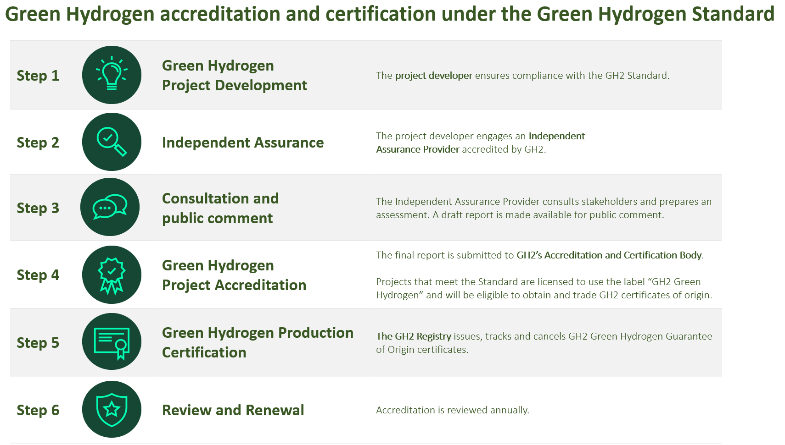
The Green Hydrogen Standard provides a clear global minimum standard, while also retaining the flexibility to accommodate local challenges and opportunities. The Standard places the onus on green hydrogen producers to demonstrate that they are addressing the environmental, social and governance performance of their projects in accordance with national laws and regulation and global best practice. The Standard seeks to ensure consistency and credibility, while also maintaining country ownership.
GH2 embraces the principle and practice of accountability by government and industry to all citizens for the stewardship of natural resources. Certification and accreditation by GH2 require that green hydrogen projects are subject to a credible, independent assessment, applying international assurance standards. The procedures emphasise openness and stakeholder consultation.

1.1 Rigorous accounting of greenhouse gas emissions – guaranteeing close to zero emissions
The Green Hydrogen Standard sets a maximum threshold for greenhouse gas emissions of [1 kg CO2e per kg H₂]. GH2 has worked with stakeholders to develop an emission measurement approach that builds on international best practice and that enables comparisons with other hydrogen production pathways. The GH2 Standard is rigorous, yet practical, with emission accounting procedures and thresholds that can be applied consistently to grid and off grid production.
The boundaries of the carbon accounting system and the thresholds at which hydrogen is considered “green” need to be clearly defined and trusted as credible by all stakeholders. With some modifications, GH2 applies the methodology for the electrolysis production pathway being developed by the International Partnership for Hydrogen and Fuel Cells in the Economy (IPHE) as outlined in the Working Paper Methodology for Determining the Greenhouse Gas Emissions Associated with the Production of Hydrogen (see Annex 1). The IPHE does not establish emissions thresholds.]. GH2’s approach addresses the storage, conversion and delivery of H2 and its derivatives. Priority is given to green ammonia, as a leading candidate for the transportation of green hydrogen for many green hydrogen project developers.

1.2 Environmental, social and governance performance
While the emissions associated with hydrogen production have received significant attention, demonstrating that green hydrogen has been produced sustainably needs to be addressed in green hydrogen certification. The Standard tracks the overall social, environmental and governance performance of green hydrogen production.
GH2 focuses on the renewable energy technologies that are the leading candidates for scaling up green hydrogen production. GH2 accreditation and certification requires the project operator to demonstrate that hydrogen is produced through the electrolysis of water with 100% or near 100% renewable energy. GH2 accreditation and certification requires renewable energy sourced from hydropower, wind, solar (solar thermal and solar photovoltaic), geothermal energy, tide, wave and other ocean energy sources. GH2 will consider opportunities to engage with project operators based on other renewable non-fossil sources on a case-by-case basis where these projects meet the same emissions and sustainability standards.
Accelerating the production and utilisation of green hydrogen requires and supports a large increase in the production and utilisation of renewable energy. In order to be accredited and certified, the Standard requires that green hydrogen project operators prepare a publicly accessible evaluation of the project’s utilisation of electricity and the impact on the energy market. The project operator must demonstrate that it has identified and implemented technically feasible and cost-effective measures that support energy efficiency or other decarbonisation options, addressing any impacts vis-à-vis access to affordable and reliable energy. The expectation is that green hydrogen projects contribute to the build-out of new renewable energy capacity and avoid leading to increased use of fossil-generated electricity elsewhere in the energy system.
The wider social and environmental impacts associated with additional renewable capacity need to be considered. Green hydrogen production facilities also need to be developed and operated responsibly and sustainably. Key questions include: Are the social and environmental impacts of new projects fully considered? Can free, prior and informed consent be verified? Are human rights respected and promoted where the energy is produced?
The Green Hydrogen Standard incorporates best practice sustainability assessments into investment analysis and project decision-making processes through an inclusive process where stakeholder views are respected and addressed. The GH2 Standard addresses the impact on affected communities, labour and working conditions, and the prohibition of all forms of slavery, child and forced labour. The use and management of water resources requires close attention, together with adherence to best practice health and safety standards in green hydrogen production, storage and transportation.

1.3 The development impact – SDG performance
The Sustainable Development Goals (SDGs) call for the betterment of global populations, while preserving the environment and guarding against a climate disaster. Green hydrogen is a unique technology and fuel that allows for scalable investment and dramatically decarbonised industry. As a system for energy production, it also promises to deliver greater energy independence for countries without natural endowments of fossil fuels as well as offering an alternative to fossil fuels. In order to achieve the SDGs and Paris Agreement targets, the energy transition must become a transformational global effort. An energy revolution is underway, but 759 million people still live without electricity and the development opportunities it provides.
Green hydrogen has enormous potential to support the achievement of the SDGs. The most obvious contributions relate to goals 7, 8 and 13 (see Policy Note 2). In addition, there are direct and indirect contributions that contribute to almost all of the SDGs. The Standard requires that green hydrogen project operators assess the project’s development impact and contribution towards achievement of the SDGs. This work should be undertaken at an early stage, with a view to maximising the development potential to support energy sector development, increase energy security and development opportunities.

The GH2 Green Hydrogen Standard
The Green Hydrogen Standard is based on a project-level certification and accreditation. It is comprised of six criteria and seven requirements.

2.1 GH2 Criteria
The Green Hydrogen Standard provides a clear global minimum standard, while also retaining the flexibility to accommodate local challenges and opportunities. The following six criteria are general principles that should be applied throughout the accreditation and certification process:
- Sovereignty and subsidiarity. GH2 acknowledges that the development of natural resources and energy markets is in the domain of sovereign governments to be exercised in the interest of their citizens and national development. To avoid duplication, demonstrating adherence to credible and comprehensive national requirements shall be deemed sufficient to meet GH2’s accreditation and certification requirements. Science-based knowledge should be applied, referring to peer-reviewed literature and internationally accepted standards.
- Proportionality (materiality). GH2 shall ensure proportionality in the accreditation and certification framework. The process should emphasize the most significant issues and impacts and allow for minor gaps / deviations in meeting the requirements where the broader objective of the requirement is met.
- Harmonization. To improve quality and efficiency, GH2 encourages alignment with international best practice and will work to ensure the interoperability of its work with organisations that are pursuing similar objectives.
- Consultation. GH2 accreditation and certification requires broad-based stakeholder consultation. All stakeholders have important and relevant contributions to make - including governments and their agencies, companies and their suppliers, financial organisations, investors and non-governmental organisations. We support the principle of free, prior and informed consent.
- Transparency. To contribute to informed public debate, the GH2 expects disclosures from project operators to be timely, comprehensive, and publicly accessible. This information should be made freely available online. Free access to, and subsequent re-use of, open data are of significant value to society.
- Concerns and appeals. The onus is on the project operator to demonstrate their adherence to GH2’s requirements. GH2 shall validate projects in accordance with the agreed procedures but is not an investigative body. Stakeholders with a concern regarding compliance with the Standard should first raise it to the attention of the project operator and the appropriate national authorities where applicable. If this is not appropriate or if the concern remains, the stakeholder may petition GH2 to consider the matter. GH2 will establish a mechanism for appeals and voicing a concern.

2.2 GH2 Requirements
The seven requirements below outline the specific requirements that must be met in order for projects to be accredited and certified by GH2. In some cases, the requirements reference policy notes. Policy notes provide additional detail and assessment criteria. Further refinements and interpretations are likely to occur and will be communicated through revised requirements and additional policy notes.
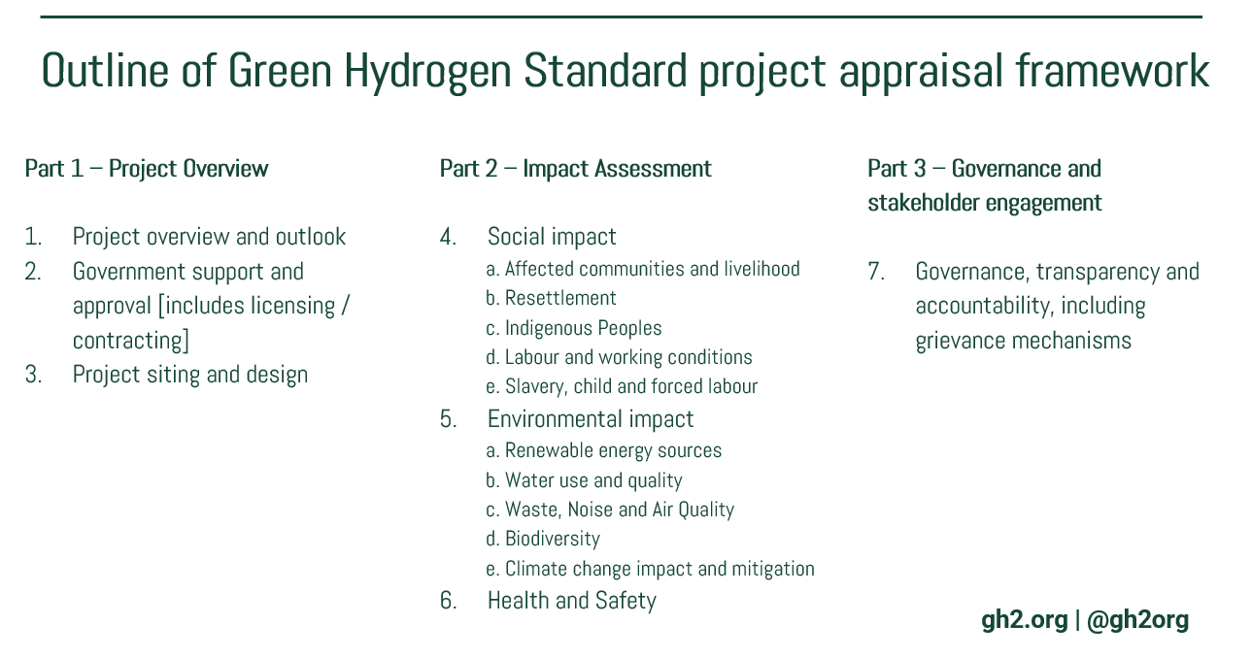
Terminology
The use of the terms ‘must’, ‘should’ and ‘required’ in the Green Hydrogen Standard indicates that a provision is mandatory and will be taken into account in the certification of the project.
The use of the term ‘expected’ in the Green Hydrogen Standard indicates that the project operator should consider the issue and document their discussions and position. Certification will consider the progress made on these issues and any barriers to meeting the expectation.
The use of the terms ‘recommended’, ‘encouraged’, ‘may wish’ and ‘could’ in the Green Hydrogen Standard indicates that a provision is optional. Certification will consider any work to address these issues, but progress will not impact certification.
The accreditation and certification procedure is set out in more detail in chapter 3.
GH2 accreditation and certification requires that the project owner and operator publish a publicly accessible overview of the project, addressing the objectives and expected outcomes and impact. This should include.
Acknowledgements
In developing these standards, the GH2 has drawn on a variety of international best practices, in particular the IFC's Environmental and Social Performance Standards, the Hydropower Sustainability Council’s Hydropower Sustainability Standard and the UN Sustainable Development Goals (SDGs).

Requirement 1 Project overview and outlook
The objective of this provision is to ensure that the project operator can demonstrate the project’s strategic fit with relevant policies and plans, and that the project is a priority option to meet identified market needs.
GH2 accreditation and certification requires that the project operator publishes a publicly accessible and transparent overview of the project addressing expected outcomes and impact. This should include:
- A simple but complete overview of the project (scope; technology used; capacities; timeframes; involved parties; local and regional impacts);
- A summary of the project’s contribution to local and national policies and plans objectives, and the project’s contribution to the UN Sustainable Development Goals, where applicable;
- A summary of the environmental, social and economic impact of the project.
- A summary of how project operators intend to meet and sustain adherence to the requirements of the GH2 Green Hydrogen standard.

Requirement 2 Stakeholder engagement and government approval
The objective of this provision is to demonstrate that the project has been subject to a proper approval process in accordance with national laws and regulations, and that any concerns regarding the project can be addressed through the appropriate channels and with the relevant government authority.
GH2 accreditation and certification requires that the project operator publishes a publicly accessible summary of the government licences and approvals associated with the project. This should address property rights, land use, water rights (if applicable) environmental, public health and foreign investment approvals as appropriate, with links to the associated documentation where publicly available. The documentation should be made available to the Independent Assurance Providers, with appropriate caveats and safeguards to protect personal and commercially sensitive information.

Requirement 3 Project siting and design
The objective of this provision is to demonstrate that the siting and design of the project has been optimised as a result of an iterative and consultative process that addresses the most significant technical, economic, financial, environmental and social considerations.
GH2 accreditation and certification requires a publicly accessible evaluation of the project siting and design options, including the renewable electricity and water sources, hydrogen production facilities, and associated storage and transportation infrastructure with appropriate attention to sensitive and protected areas.

Requirement 4 Social impact
International best practice highlights the importance of integrated assessments to identify: (1) the social impacts, risks, and opportunities of projects; (2) effective community engagement through disclosure of project-related information and consultation with local communities on matters that directly affect them; and (3) the project operator’s management of environmental and social performance throughout the life of the project.
The expectation is that project have been subject to social impact assessment (SIA) or other similar assessment to help understand the potential impacts that a proposed project may have on a community. This should include a baseline study of the community’s existing social environment. The baseline information is then used to help predict any social impacts the community may face, or changes that may occur to the existing social environment, by introducing the proposed project. The expectation is that these assessments have been carried out in accordance with applicable regulatory requirements, including appropriate stakeholder consultation and publication of the results. It is expected that the finding from this work have been incorporated into a community engagement plan (or similar) that addresses opportunities to create and contribute to social value in the communities that host the project.

Requirement 4A Affected communities and livelihood
The objective of this provision that the livelihoods and living standards are improved for project-affected communities and that life, property and community assets and resources are protected from the consequences of the project.
GH2 accreditation and certification requires that issues relating to project affected communities have been identified through an assessment process utilising local knowledge; and monitoring of project impacts and effectiveness of management measures is being undertaken during project implementation appropriate to the identified issues.
GH2 accreditation and certification requires that public health issues relevant to project implementation and operation have been identified through an assessment process utilising appropriate expertise; and monitoring is being undertaken during the project implementation stage appropriate to the identified issues.
GH2 accreditation and certification requires that project operators committed to identifying, assessing and mitigating human rights impacts, providing access to remedy through effective grievance mechanisms, and ensuring continuous improvement.
The Green Hydrogen Standard requires that green hydrogen project operators assess the project’s development impact and contribution towards the SDGs. In the case that commitments to additional benefits or benefit sharing have been made, the expectation is that the project operator has established a system to monitor and report on the delivery of these commitments.

Requirement 4B Resettlement
The objective of this provision that the dignity and human rights of those physically displaced are respected; that these matters are dealt with in a fair and equitable manner; and livelihoods and standards of living for resettles and host communities are improved.
When companies seek to acquire land for their business activities, it can lead to relocation and loss of shelter or livelihoods for communities or individual households. “Involuntary resettlement” refers both to physical displacement (relocation or loss of shelter) and to economic displacement (loss of assets or access to assets that leads to loss of income sources or other means of livelihood) as a result of project-related land acquisition and/or restrictions on land use. Resettlement is considered involuntary when affected persons or communities do not have the right to refuse land acquisition or restrictions on land use that result in physical or economic displacement.
In accordance with IFC PS5, GH2 accreditation and certification requires that project operators avoid involuntary resettlement wherever possible and to minimise its impact on those displaced through mitigation measures such as fair compensation and improvements to and living conditions. Active community engagement throughout the process is essential.

Requirement 4C Indigenous Peoples
The objective of this provision is to ensure that the project respects the dignity, human rights, aspirations, culture, lands, knowledge, practices and natural resource-based livelihoods of Indigenous Peoples in an ongoing manner throughout the project life.
Indigenous peoples may be particularly vulnerable to the adverse impacts associated with project development, including risk of impoverishment and loss of identity, culture, and natural resource-based livelihoods.
In accordance with IFC PS7, GH2 accreditation and certification requires that business activities minimise negative impacts, foster respect for human rights, dignity and culture of indigenous populations, and promote development benefits in culturally appropriate ways.
GH2 accreditation and certification requires informed consultation and participation with Indigenous peoples throughout the project process. The expectation is that project operators adhere to the principle of Free, Prior and Informed Consent

Requirement 4D Labour and working conditions
The objective of this provision is to ensure that workers are treated fairly and are protected
GH2 accreditation and certification requires that project operators undertake an assessment of human resource and labour management requirements for the project, including project occupational health and safety (OH&S) issues, risks, and management measures.
GH2 accreditation and certification requires that occupational health and safety (OH&S) issues and risks; and processes are in place to identify any emerging or ongoing issues, and to monitor if management measures are effective.

Requirement 4E Slavery, child and forced labour
The objective of this provision is to ensure that the project protect workers, including vulnerable categories of workers such as children, migrant workers, workers engaged by third parties, and workers in the client’s supply chain.
GH2 accreditation and certification requires that project operator does not employ children in any manner that is economically exploitative, or is likely to be hazardous or to interfere with the child’s education, or to be harmful to the child’s health or physical, mental, spiritual, moral, or social development.
GH2 accreditation and certification requires that project proponent does not employ forced labour, which consists of any work or service not voluntarily performed that is exacted from an individual under threat of force or penalty. This covers any kind of involuntary or compulsory labour, such as indentured labour, bonded labour, or similar labour-contracting arrangements. The project operator will not employ trafficked persons.
GH2 accreditation and certification expects that project operators work in collaboration with their suppliers to eradicate modern slavery.

Requirement 5 Environmental impact
International best practice highlights the importance of integrated assessments to identify: (1) the environmental, risks, and opportunities of projects; (2) effective community engagement through disclosure of project-related information and consultation with local communities on matters that directly affect them; and (3) the project operator’s management of environmental and social performance throughout the life of the project.
The expectation is that the project has been subject to an environmental impact assessment, i.e., a rigorous process identifying, predicting, evaluating and mitigating the biophysical, social, and other relevant effects of the project in accordance with applicable regulatory requirements, including appropriate stakeholder consultation and publication of the results. It is also expected that project operator has established an environmental management plan to safeguard and improve environmental performance.

Requirement 5A Renewable energy sources
The objective of this provision is to demonstrate that green hydrogen is produced from renewable energy sources with close to zero emissions.
GH2 accreditation and certification requires the project operator to demonstrate that hydrogen is produced through the electrolysis of water with 100% or near 100% renewable energy. GH2 accreditation and certification requires renewable energy sourced from hydropower, wind, solar (solar thermal and solar photovoltaic), geothermal energy, tide, wave and other ocean energy sources. GH2 will consider proposals from project operators based on other renewable non-fossil sources on a case-by-case basis. The project operator must demonstrate that project meets equivalent emissions and sustainability standards.
GH2 accreditation and certification requires that the project operator undertakes an evaluation of the project’s utilisation of electricity and the impact on the energy market including, where applicable, the impact of their operations on the greenhouse gas emissions from the electricity grid. The project operator must demonstrate that it has identified and implemented technically feasible and cost-effective measures that support energy efficiency or other decarbonisation options, addressing any impacts vis-à-vis access to affordable and reliable energy. Where the evaluation concludes that the project may lead to a significant utilisation of renewable energy from the electricity grid and/or increased greenhouse gas emissions from the electricity grid, there is an expectation that the project operator has identified and implemented technically feasible and cost-effective measures to support the deployment of additional renewable energy capacity.
Green hydrogen producers may count electricity taken from the grid as fully renewable if they have concluded one or more power purchase agreements (PPAs) with operators producing renewable electricity in one or more installations, generating renewable electricity for an amount that is at least equivalent to the amount of electricity that is claimed as fully renewable and the electricity claimed is effectively produced in this or these installations. PPAs should make use of credible guarantee of origin certification schemes (or similar proofs) where available. There is an expectation that the project operator has addressed temporal correlation (ensuring that the electrolysers’ demand matches the renewable power generation as a minimum on an intra-day basis) as well as a geographical correlation (ensuring that the electrolyser and the renewable power generation covered by the PPA are located in the same power market). Where regulatory bodies have imposed additional requirements on temporal or geographical correlation between the consumption of electricity by the electrolysers and the generation of the additional renewables-based electricity, GH2 certification requires that these requirements are met.
Up to [5%] of ‘grey’ electricity may be consumed by electrolysers in a given year if it can be reasonably demonstrated that there have been technical or market constraints requiring such use. GHG emissions resulting from the use of this ‘grey’ electricity consumption need to be calculated according to the rules applied by the UNFCCC to calculate the emission factor for an electricity system). The overall threshold for the GHG intensity of produced hydrogen (1kg Co2 / kg H2) must not be exceeded in a given calendar year.

Requirement 5B Water use and quality
The objective of this provision is to ensure that green hydrogen projects address the availability and sustainable management of water and sanitation, particularly incorporating the need to address risks of reducing water access/exacerbates water stress.
GH2 accreditation and certification requires a publicly accessible evaluation of the project’s utilisation of water and the project’s approach to wastewater treatment and water pollution, referencing, where appropriate, applicable national standards. The project operator must demonstrate that it has identified and implemented technically and financially feasible and cost-effective measures for improving efficiency in its consumption of water, particularly in risks associated with water access and water stress. Such measures will integrate the principles of cleaner production into product design and production processes with the objective of optimising water consumption and minimising water pollution.
This could include:
- A description of how the project interacts with water, including how and where water is withdrawn, consumed, and discharged, and the water-related impacts caused or contributed to, or directly linked to the project;
- A description of total water consumption from all areas, with a focus on areas with water stress;
- A description of how water-related impacts are addressed, including how the project operator works with stakeholders to steward water as a shared resource;
- A description of any minimum standards set for the quality of effluent discharge, and how these minimum standards were determined.

Requirement 5C Waste, Noise and Air Quality
The objective of this provision is to ensure that the negative environmental and social impacts associated with the project are managed; avoidance, minimisation, mitigation, compensation and enhancement measures are implemented; and environmental and social commitments are fulfilled.
GH2 accreditation and certification requires that waste, noise and air quality issues relevant to project implementation and operation have been identified through an assessment process utilising appropriate expertise and that monitoring is being undertaken during the project implementation stage appropriate to the identified issues.

Requirement 5D Biodiversity
The objective of this provision is to ensure that: (1) there are healthy, functional and viable aquatic and terrestrial ecosystems in the project-affected area that are sustainable over the long-term; (2) biodiversity impacts arising from project activities are managed responsibly; (3) that ongoing or emerging biodiversity issues are identified and addressed.
GH2 accreditation and certification requires that biodiversity issues relevant to project implementation and operation have been identified through an assessment process utilising appropriate expertise; and that monitoring is being undertaken during the project implementation stage appropriate to the identified issues.

Requirement 5E Climate change impact and mitigation
The objective of this provision is to demonstrate that green hydrogen is produced from renewable energy sources with close to zero emissions.
The Green Hydrogen Standard requires independent verification (through the accreditation and certification process) that green hydrogen production facilities have robust systems to accurately and comprehensively measure the greenhouse gas emissions for production periods / shipments, including appropriate documentation for the purposes of certification.
GH2 accreditation and certification requires that projects that operate at [<1 kg CO2e per kg H2] taken as an average over a 12-month period as per the electrolysis production pathway defined by the International Partnership for Hydrogen and Fuel Cells in the Economy (IPHE) as outlined in the Working Paper Methodology for Determining the Greenhouse Gas Emissions Associated with the Production of Hydrogen (see Policy Note 1).
In addition, GH2 accreditation and certification expects project operators to calculate and report on the indirect GHG emissions associated with H2 production processes (e.g., relating to water use and waste disposal), and the emissions associated with the storage, conversion and delivery of H2 and its derivatives. GH2 will develop methods and thresholds with a view these becoming a requirement for accreditation and certification by 31 December 2023.
GH2 also encourages project operators to calculate and report on the embodied emissions associated with green hydrogen production, including embodied emissions associated with: (i) purchased energy (grid) and energy produced on site (off grid); (ii) construction of H2 production facilities, and (iii) construction of storage, conversion and delivery infrastructure. GH2 will collaborate with partner organizations to develop and apply methods consistently to all energy providers.
The GH2 Board will review the performance of GH2 accredited projects on an annual basis, with the expectation that the boundaries of the emissions assessment framework can be widened, and that the emissions thresholds can be lowered in accordance with emerging best practice.

Requirement 6 Health and Safety
The objective of this provision is to demonstrate that the livelihoods and living standards impacted by the project are improved relative to pre-project conditions for project-affected communities; and that life, property and community assets and resources are protected from the consequences of any infrastructure and operational safety risks.
GH2 accreditation and certification expects project operators to have undertaken an assessment of human resource and labour management requirements for the project, including project occupational health and safety (OH&S) issues, risks, and management measures.

Requirement 7 Governance, transparency and accountability
1. General. GH2 accreditation and certification requires that he project operator has sound corporate business structures, policies and practices; addresses transparency, integrity and accountability issues; can manage external governance issues (e.g., institutional capacity shortfalls, political risks including transboundary issues, public sector corruption risks); can ensure compliance; and procurement processes are equitable, transparent and accountable.
2. Anti-corruption compliance. Corruption deprives communities of the benefits that should flow from the development of natural resources and undermines decision making. GH2 accreditation and certification requires that the project operator establishes codes of conduct and anti-corruption standards that clearly prohibit bribery and corruption, including facilitation payments to government officials to obtain routine services. The standards should address the obligations for employees and contractors and include a risk-based system for due diligence. Project operators are encouraged to incorporate anti-corruption compliance into business key performance indicators that ultimately determine employee remuneration.
3. Transparency. The project operator is expected to publicly disclose key information of public interest about its corporate structure, contractual terms related to the project and financial transactions with the government. Disclosures are expected to be made in consultation with citizens and local communities.
- Beneficial ownership transparency. Project operators are encouraged to disclose legal and beneficial ownership, including the identity(ies) of their beneficial owner(s), the level of ownership and details about how ownership or control is exerted. Where possible, this information should be incorporated in existing filings by companies to corporate regulators, stock exchanges or agencies regulating the project.
- Contract transparency. Project operators are encouraged to disclose the full text of any contract, concession, production-sharing agreement or other agreement granted by, or entered into by, the project operators which provides the terms attached to the utilisation of electricity and water and the production of green hydrogen.
- Tax and subsidy transparency. Project operators are encouraged to comprehensively disclose their payments they make to governments at both central and subnational level, and subsidies awarded to the project operator as individual subsidies or as part of a subsidy scheme. Types of payments to government include taxes levied on the income, production or profits of companies, royalties, dividends, licence fees, rental fees and other considerations for licences or concessions.

Accreditation and Certification
The Green Hydrogen Standard incorporates an accreditation and certification process in three stages:

3.1 Early-stage commitment and support
Project developers are invited to work with GH2 from the earliest stages of green hydrogen project development. Project developers commit to the GH2 Principles and confirm their intention to seek GH2 accreditation and certification. GH2 provides project developers with tools that can be used throughout early-stage concept and pre-feasibility work in consultation with stakeholders and host communities prior to final government approvals and final investment decision. Early commitment to the Green Hydrogen Standard can also be useful in marketing products and negotiating offtake agreements. The first stage is purposefully low cost and “light touch”, focussed on maximising the efficacy, efficiency and development potential of green hydrogen projects, and the early identification and amelioration of any environment, social and governance risks.

3.2 Independent appraisal of Green Hydrogen Projects
Project operators seeking accreditation should undertake the necessary preparatory work to demonstrate their project’s adherence to the Green Hydrogen Standard as outlined in the previous section. GH2 will accredit Independent Assurance Providers (IAPs) authorised to review projects in accordance with the Standard. Project operators would engage an IAP (at their own cost) to assess adherence to the Green Hydrogen Standard.
By 30 June 2022 the GH2 Board will issue Policy Notes addressing the procedure for the appointment of Independent Assurance Providers (IAPs) and standard terms of Reference for the engagement of Independent Assurance Providers (IAPs).

3.3 Accreditation of Green Hydrogen Projects and Certification of Green Hydrogen Production
The final report from the Independent Assurance Provider is submitted to GH2’s Accreditation and Certification Body. Projects that meet the Standard are licensed to use the label “GH2 Green Hydrogen” and will be eligible to obtain and trade GH2 certificates of origin. Projects that do not meet the standard may be re-submitted. The GH2 Registry will tracks GH2 the issuance, transfers and cancelation of GH2 Certificates.
By 31 December 2022, GH2 will issue Policy Notes addressing the Terms of Reference for the Establishment of the GH2 Accreditation and Certification Body and associated procedures and the Terms of Reference for the establishment of the GH2 Registry.
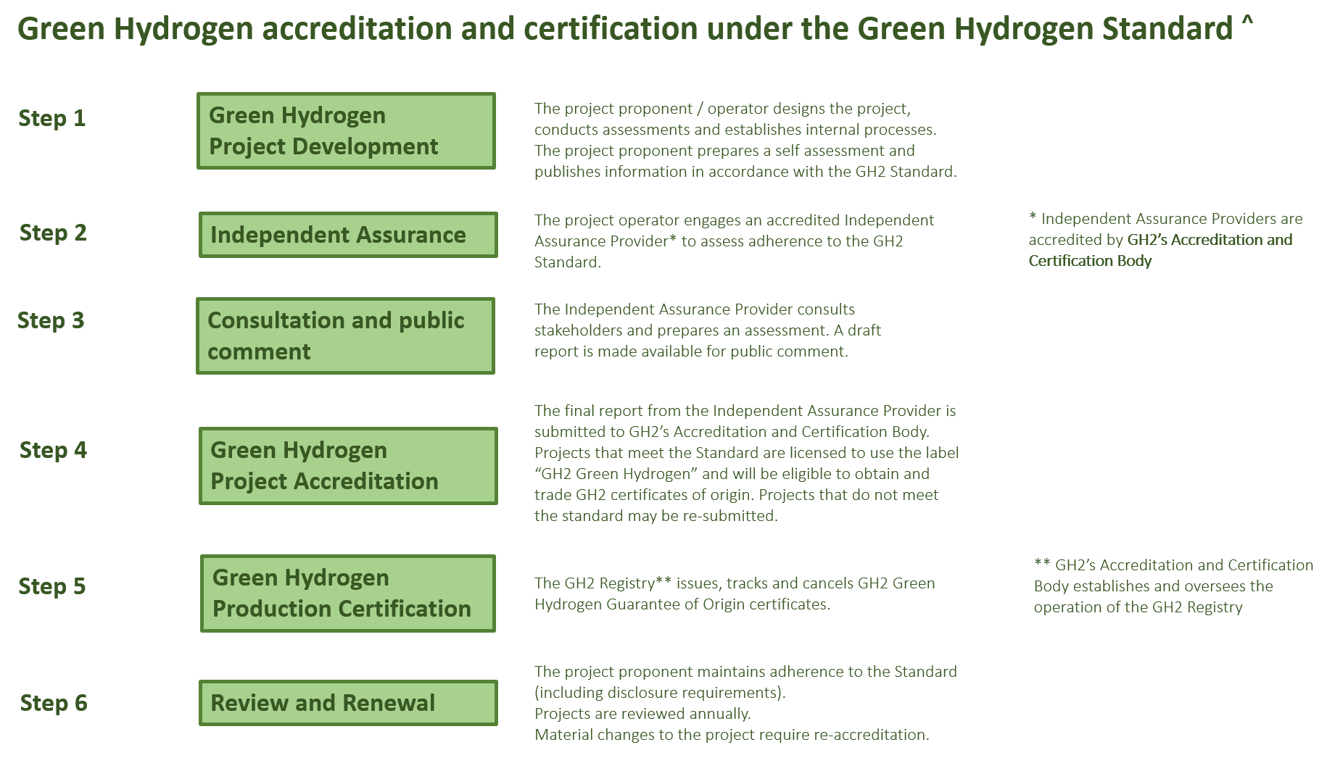

GH2 Policy Notes
Policy notes provide additional detail on issues covered in sections 2 and 3. The GH2 Board will refine and approve additional policy notes building on lessons learned from accreditation and certification, taking into account feedback from project operators and other stakeholders.

Policy Note 1 – GH2 methodology for GHG emissions measurement
- The Green Hydrogen Standard applies the methodology for the electrolysis production pathway being developed by the International Partnership for Hydrogen and Fuel Cells in the Economy (IPHE) as outlined in the Working Paper Methodology for Determining the Greenhouse Gas Emissions Associated with the Production of Hydrogen. Based on discussions with stakeholders, some minor refinements have been adopted. This policy note will be reviewed on a regular basis, taking into account feedback from project operators and other stakeholders and subsequent refinements to the IPHE methodology. This will include a clarification of the methods to be followed for calculating GHG emissions for Green Hydrogen derivates, such as Green Ammonia.

- Technology Scope (as per IPHE). There are currently three main electrolyser technologies, distinguished by the electrolyte (and associated production temperatures): alkaline electrolyser, polymer electrolyte membrane (PEM) electrolyser and solid oxide (SOEC) electrolyser. This methodology may be applied to any other electrolysis technologies.

- Electrolysis Process Description (as per IPHE). A water electrolysis cell consists of an anode and a cathode separated by a membrane immerged in an electrolyte (a conductive solution). When connected to a direct current power supply, electricity flows through the electrolyte and causes the water to split into hydrogen and oxygen. Each electrolyser system consists of a stack of electrolysis units, a gas purifier and dryer and an apparatus for heat removal.

Hydrogen and oxygen gas products must be purified, dried and cooled prior to storage and/or delivery to market, subject to required product specifications. The oxygen gas must be safely vented to the atmosphere. Alternatively, pending availability of appropriate markets, this oxygen may be sold as a co-product.

Within this emissions accounting framework, electrolysers are assumed to have an outlet pressure of 3 MPa. Depending on the design of the electrolyser, an electrolysis system may require compression to achieve 3 MPa pressure or drying. In that case, energy consumption for achieving this and the associated emission have to be calculated and included.
Process diagram for hydrogen produced from electrolysis
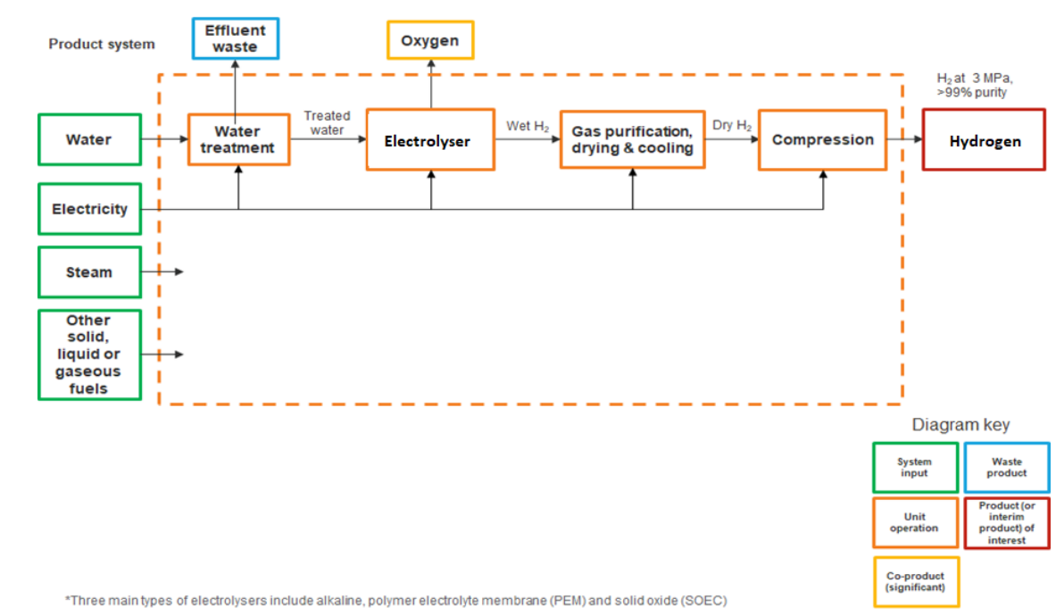
- Emissions Sources in Electrolysis (as per IPHE). GHG emissions associated with electrolysis are subject to the nature of electricity supply for electrolysis as electricity can be sourced from the grid (noting that this may be impacted by contracting of renewable electricity supply and associated instruments), generated on-site via the combustion of liquid, gaseous and/or solid fuels (in this case, this would be the key emissions source) or supplied from an off-grid on-site system. Each process unit or stage in the electrolysis process contains emissions sources outlined below.
GHG emissions summary for electrolysis
Process unit/stage | Key emissions sources | Other emissions sources
Water supply and treatment | Electricity for purification and filtration.
Hydrogen production | Electricity for electrolyser units | Steam (where purchased).  Liquid, solid and/or gaseous fuel combustion for steam generation.  Liquid, solid and/or gaseous fuel combustion for electricity generation.
Hydrogen compression, purification, drying and cooling | Electricity for relevant units | Steam (where purchased)  Solid, liquid and/or gaseous fuel combustion for relevant units and/or steam generation.
- The process, methods and requirements of hydrogen life cycle impact assessment are as per IPHE §6.3 (and ISO 14044) with one modification. Specifically: the IPHE methodology stipulates: “the GHG impact of electricity generation from wind, solar photovoltaic, hydropower and geothermal will be assumed to be zero” (§6.2.3 p27). GH2 notes that these emissions may be > 0, and requires that these emissions are quantified.

Forthcoming Policy Notes (31 December 2022)
- Procedure for the appointment of Independent Assurance Providers (IAPs)
- Standard terms of Reference for the engagement of an Independent Assurance Provider.
- Terms of Reference for the GH2 Accreditation and Certification Body.
- Terms of Reference for the GH2 Registry.

IPHE (2021) Methodology for Determining the Greenhouse Gas Emissions Associated with the Production of Hydrogen https://www.iphe.net/iphe-working-paper-methodology-doc-oct-2021
United Nations (2015) The 2030 Agenda for Sustainable Development. https://sdgs.un.org/goals
United Nations (2021) Department of Economic and Social Affairs. Sustainable Development. https://sdgs.un.org/news/proposed-global-roadmap-shows-how-universal-access-sustainable -energy-can-be-achieved-2030
It is important to emphasise that this is not a waiver of requirements. The onus is on the project operator to demonstrate their adherence to GH2’s requirements. The credibility and comprehensiveness of national requirements will be considered as part of the independent appraisal process, including broad based consultation with project stakeholders.
IFC (2021) Performance Standards. https://www.ifc.org/wps/wcm/connect/Topics_Ext_Content/IFC_External_Corporate_Site/Sustainability-At-IFC/Policies-Standards/Performance-Standards
Hydropower Sustainability Council (2021) Hydropower Sustainability Standard https://static1.squarespace.com/static/5c1978d3ee1759dc44fbd8ba/t/61379550f76c7d53f2b0f446/1631032662564/Hydropower+sustainabiity+standard+310821+01b.pdf
IFC (2012) Performance Standard 1. https://www.ifc.org/wps/wcm/connect/topics_ext_content/ifc_external_corporate_site/sustainability-at-ifc/policies-standards/performance-standards/ps1
IFC (2012) Performance Standard 5: Land Acquisition and Involuntary Resettlement. https://www.ifc.org/wps/wcm/connect/topics_ext_content/ifc_external_corporate_site/sustainability-at-ifc/policies-standards/performance-standards/ps5
IFC (2012) Performance Standard 7: Indigenous Peoples. https://www.ifc.org/wps/wcm/connect/topics_ext_content/ifc_external_corporate_site/sustainability-at-ifc/policies-standards/performance-standards/ps7
IFC (2012) Performance Standard 2: Labor and Working Conditions. https://www.ifc.org/wps/wcm/connect/topics_ext_content/ifc_external_corporate_site/sustainability-at-ifc/policies-standards/performance-standards/ps2
IFC (2012) Performance Standard 1
TBC
In accordance with IFC (2012) Performance Standard 3: Resource Efficiency and Pollution Prevention, “the term ‘pollution’ includes: “both hazardous and non-hazardous chemical pollutants in the solid, liquid, or gaseous phases, and includes other components such as pests, pathogens, thermal discharge to water, GHG emissions, nuisance odors, noise, vibration, radiation, electromagnetic energy, and the creation of potential visual impacts including light”.
https://www.iphe.net/iphe-working-paper-methodology-doc-oct-2021
https://gh2.org/about/our-principles
IPHE (2021) Methodology for Determining the Greenhouse Gas Emissions Associated with the Production of Hydrogen https://www.iphe.net/iphe-working-paper-methodology-doc-oct-2021
6 For technologies whose typical hydrogen output pressure at gate is 1 MPa or lower, one can also report in addition to the 3 MPa, GHG emission at 1 MPa with the calculation result of GHG emission adjusted to 3 MPa which requires additional energy to increase the output pressure.
Where high temperature SOEC are utilised
Where high temperature SOEC are utilised.
Where on-site electricity generation is non-renewable.

